

Benefits provided by SafeGuard Health Plans, Inc.,
a MetLife company
200 Park Avenue, New York, New York 10166

APPLICATION FOR GROUP DENTAL BENEFITS

The applicant named below is applying for a Group Contract to provide dental benefits for the persons specified below.

APPLICANT DATA

1. Full legal name of Applicant:
2. Address: City: State: Zip:

CONTRACT EFFECTIVE DATE
The Group Contract’s effective date will be , subject to MetLife’s acceptance of this application.

CONTRACT SITUS
The Group Contract will be issued for delivery in and governed by the laws of California.

 | COVERAGE DATA |  | Employees / Members Only | Employees / Members  and Dependents
 |  | Dental Benefits

PREPAYMENT FEE DATA
Prepayment Fees will be paid: monthly quarterly annually other:
Attached is an advance payment of: $

AGREEMENT
The Applicant signing below agrees to accept the terms and provisions of the Group Contract, including its Exhibits, amendments and endorsements, if any.
Fraud Warning. For your protection California law requires the following to appear on this form: Any person who knowingly presents false or fraudulent information to obtain or amend insurance coverage or to make a claim for the payment of a loss is guilty of a crime and may be subject to fines and confinement in state prison.

(Signature of Applicant’s Legal Representative) (Print Name and Title of Legal Representative)

Signed at:
(City) (State) Date:

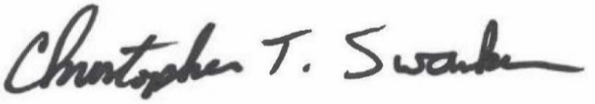 President Chris Swanker
(SafeGuard Representative) (Representative’s title) (Print Name of Representative)

